

Yalitza has been a woman of great admiration because although she is of indigenous descent and her mother was a housewife, she got ahead, also because she was discriminated against and mistreated when she worked in a restaurant just because she was indigenous and she defended her rights, she was shy and learned to speak Mixtec.

¿who is it?

Mexican actress and teacher of Mixtec descent, who rose to fame for the movie "Roma"

I participate in the film Rome

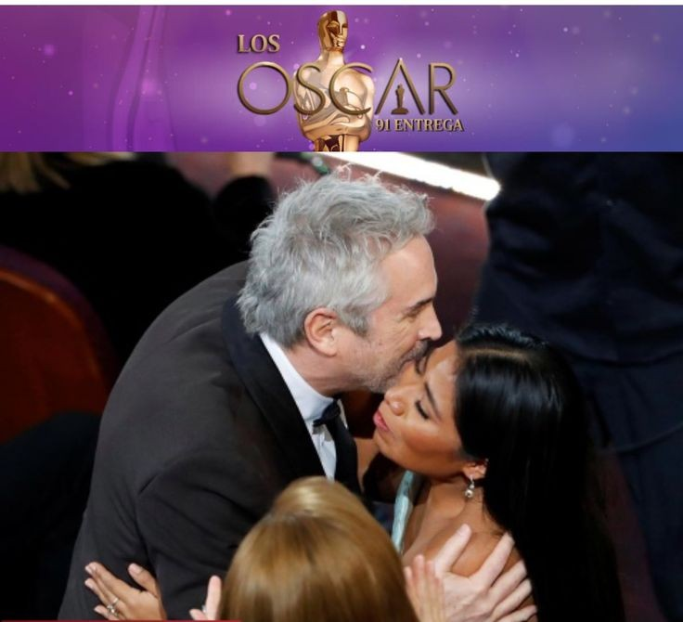

Oscar nominated

YALITZA APARICIO